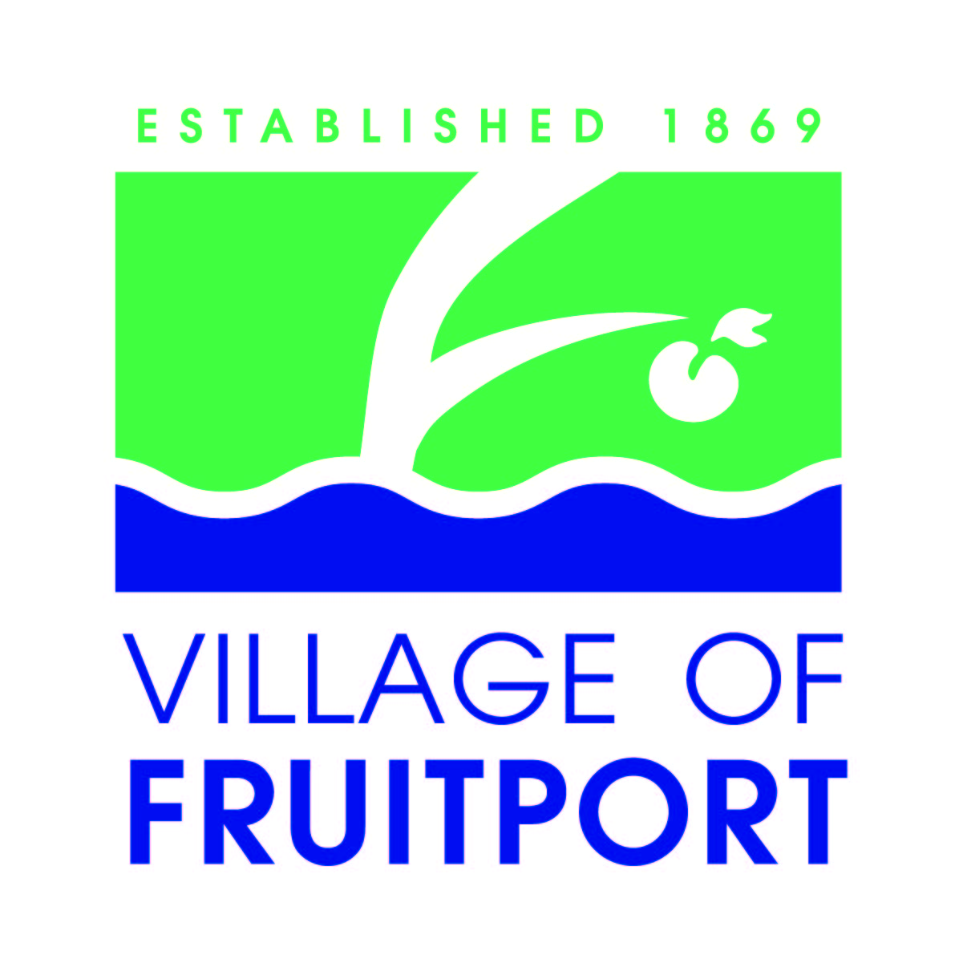
Fruitport Village Recreation Plan Update
- Public Meeting –
November 4, 2024

1. What do you like about the existing recreation opportunities in Fruitport Village?

2. What don’t you like about the existing recreation opportunities in Fruitport Village, or what would you like to see changed?

3. What new programs or facilities would you like to see in Fruitport Village?

4. Other comments regarding current and future recreation opportunities in Fruitport Village:

